*The script can be found attached to the Support Case (7604) in TrueCloud’s NetSuite environment*

# Process

* When a sale Dispatch is saved and the Status is “Delivery Completed”, execute the Asset Disposal Library which will create the Invoice, Journal, and dispose of the Asset.
* Close the Sales Order
  + It should not be billed as it will be billed by using the Asset Disposal Library

At this point the process is manual for ProBox, they might be OK with doing this manually moving forward, but will likely be expecting further automation. This additional automation might look like:

* Write a User-Event script that upon *Creation* of an Invoice performs a lookup for that Invoice being present on an Asset in the Sales Invoice field, if a match is not found, do not continue (but refer to disclaimer)
* Once the Asset is know, find the Sales Order that was associated with the Asset and gather the Item and other relevant information
  + This will need to be done by traversing through the Dispatch record that initiated the process. ProBox *must* be setting either the Fixed Asset or the ProBox Number field for this to function
  + [Invoice 12080](https://system.na1.netsuite.com/app/accounting/transactions/custinvc.nl?id=181151) is a good example of the Items/fields that ProBox updates manually after having run the disposal manually
* Update the Invoice with the additional Items/fields from the Sales Order, flag the Invoice as having been “Automatically Disposed”
  + This would be a new field, and would help to ensure that the Invoice has been truly updated to reflect the Contract that it was associated to originally

# Examples / Screenshots

Test-Asset that was created and disposed of in ProBox’s environment (since deleted):

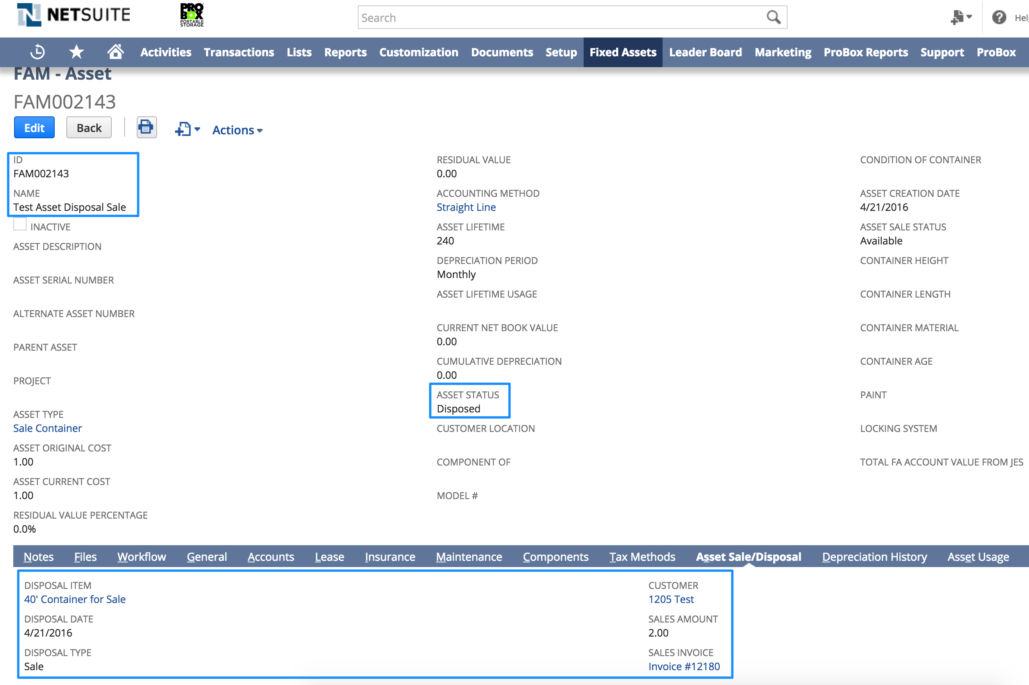

The BG – Process Instance record that’s created, after this is created it’s pushed into the Scheduled Script

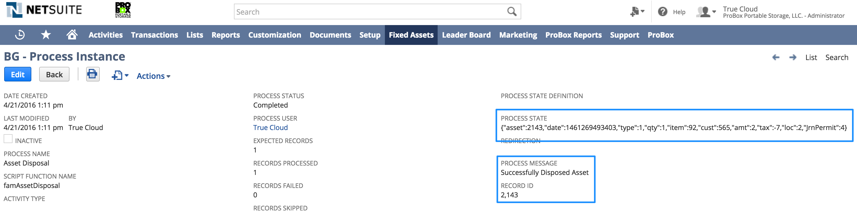

This is an example of the script that’s called to execute this

